扫一扫，

获得更多资讯

服务热线：

版本09/2021

**Service Manual**

**EK18RF/RFL  
Stand Up Forklift**



warning

You must understand the operation instructions in this manual before using it.

Note:

· Please check the last page of this document and nameplate for all current product type identification.

Keep it for future use

**Manual**

1.  Maintenance List 1

a. Overview of main components  2

b. Lubrication point 3

c. Check and refill hydraulic oil 4

d. Check the fuse 5

2. Fault Analysis 6

a. Common Fault analysis 7

b. The fault code is displayed 8

3. Wiring/circuit Diagram 9

a、Schematic diagram and wiring diagram 10

b、 Hydraulic circuit  11

4. Main parts disassembling 2

a. Battery brake adjustment 12

b Drive assembly disassembly 13

c. Drive brake disassembly 14

d. Drive internal gear bearings 15

e. Handle assembly 16

f. Frame breakdown 18

g. Pump station motor 26

5、CURTIS Handheld Unit 19

**1 Regular maintenance**

Only qualified and trained personnel should perform maintenance work on this vehicle.

Before maintenance, remove the cargo from the fork and lower the fork to the lowest position.

If you need to lift the vehicle, use the specified lashing or jacking equipment.Before operation, place safety devices (such as designated jacks, wedges or wood blocks) under the vehicle to prevent accidental drop, movement or sliding.

Use the original parts approved and released by your dealer.

Please consider that hydraulic fluid leakage may lead to machine failure and accidents.

Pressure valve adjustment is only allowed by trained service technician.

If you need to replace wheels, casters must be round and free of abnormal wear.

Check the items on the maintenance list.

## 1.1Maintenance List

|  |  |  |  |  |  |
| --- | --- | --- | --- | --- | --- |
|  | | Interval (month) | | | |
| 1 | 3 | 6 | 12 |
| The hydraulic system | | | | | |
| 1.1 | Check the function of hydraulic system |  | • |  |  |
| 1.2 | Check hoses, piping and joints for tightness, sealing and damage |  | • |  |  |
| 1.3 | Inspect cylinder block and piston for damage, sealing and fixation |  |  | • |  |
| 1.4 | Visually inspect the door stand roller and inspect the roller surface for wear |  |  | • |  |
| 1.5 | Inspect forks and loading parts for wear and loss |  |  | • |  |
| 1.6 | Check load chain Settings and re-tensioning if necessary |  |  | • |  |
| 1.7 | Check oil level in fuel tank |  |  | • |  |
| 1.8 | Replacement hydraulic fluid |  |  |  | • |
| Mechanical systems | | | | | |
| 2.1 | Check the fork for deformation and breakage |  | • |  |  |
| 2.2 | Check chassis for deformation and cracking |  | • |  |  |
| 2.3 | Check that all screws are in place |  | • |  |  |
| 2.4 | Check gear box for noise and leakage |  | • |  |  |
| 2.5 | Check wheel for deformation and damage |  | • |  |  |
| 2.6 | Lubricated steering bearing |  |  |  | • |
| 2.7 | Check and lubricate the pivot points |  | • |  |  |
| 2.8 | Lubricating grease nozzle | • |  |  |  |
| Electrical system | | | | | |
| 3.1 | Check whether power cables are damaged |  | • |  |  |
| 3.2 | Check the electrical connections |  | • |  |  |
| 3.3 | Check the function of the emergency switch |  | • |  |  |
| 3.4 | Check whether the power drive system is noisy or damaged |  | • |  |  |
| 3.5 | Test electricity meter |  | • |  |  |
| 3.6 | Check whether the correct fuse is used |  | • |  |  |
| 3.7 | Detect warning signals |  | • |  |  |
| 3.8 | Check the current contactor |  | • |  |  |
| 3.9 | Check frame for leakage (insulation test) |  | • |  |  |
| 3.10 | Check the function and wear of the drive controller |  | • |  |  |
| 3.11 | Check the electrical system that drives the motor |  | • |  |  |
| [traveling](D:/360%E5%AE%89%E5%85%A8%E6%B5%8F%E8%A7%88%E5%99%A8%E4%B8%8B%E8%BD%BD/Youdao/Dict/8.9.6.0/resultui/html/index.html#/javascript:;) [system](D:/360%E5%AE%89%E5%85%A8%E6%B5%8F%E8%A7%88%E5%99%A8%E4%B8%8B%E8%BD%BD/Youdao/Dict/8.9.6.0/resultui/html/index.html#/javascript:;) | | | | | |
| 4.1 | Check the gearbox for abnormal sound |  |  | • |  |
| 4.2 | Check the driving mechanism and grease it |  | • |  |  |
| 4.3 | Inspect driving and steering wheels for wear and damage |  |  | • |  |
| 4.4 | Check wheel bearing and fastening condition |  |  | • |  |
| 4.5 | Check the air gap of the electromagnetic brake |  |  | • |  |
| 4.6 | Check the lifting, forward and backward tilt and left and right movement of the door frame |  | • |  |  |
| 4.7 | Check and adjust braking effect |  | • |  |  |
| [Energy](D:/360%E5%AE%89%E5%85%A8%E6%B5%8F%E8%A7%88%E5%99%A8%E4%B8%8B%E8%BD%BD/Youdao/Dict/8.9.6.0/resultui/html/index.html#/javascript:;) [supply](D:/360%E5%AE%89%E5%85%A8%E6%B5%8F%E8%A7%88%E5%99%A8%E4%B8%8B%E8%BD%BD/Youdao/Dict/8.9.6.0/resultui/html/index.html#/javascript:;) | | | | | |
| 5.1 | Check the voltage of the battery |  | • |  |  |
| 5.2 | Check that battery cables are securely connected and grease the electrodes if necessary |  | • |  |  |
| 5.3 | Check whether the battery cover is damaged |  | • |  |  |
| 5.4 | Check the main cable for damage |  |  | • |  |
| 5.5 | Check the start up protection program during charging |  |  | • |  |
| Monolithic Construction | | | | | |
| 6.1 | Check all labels for clarity and completeness | • |  |  |  |
| 6.2 | Check the frame for damage |  | • |  |  |
| 6.3 | Check the fixing condition of lifting door frame |  |  | • |  |
| 6.4 | Run a test run | • |  |  |  |

1.2Lubrication point.

Lubricate marked points according to maintenance list.Required grease specification: DIN 51825 standard grease

Pic1：transmission chain

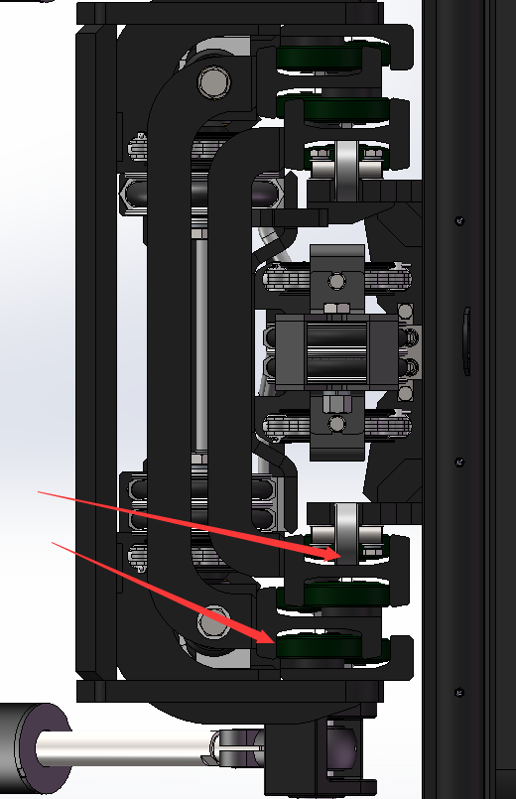

Pic2：The rail of gantry

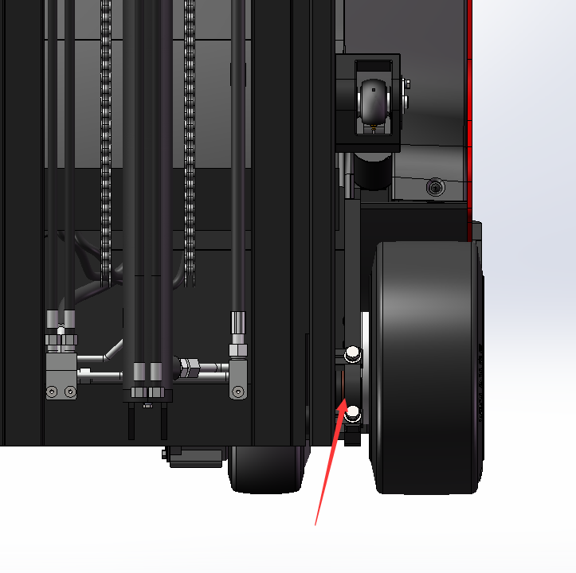

Pic3：Drive axle clamp



1.3**Check and refill hydraulic oil**

Recommended hydraulic oil model according to temperature:

|  |  |  |
| --- | --- | --- |
| Ambient temperature | –5℃~25℃ | >25℃ |
| mark | HVLP 32，  DIN 51524 | HLP 46，  DIN 51524 |
| Viscosity | 28.8-35.2 | 41.4 - 47 |
| Oil | 19-20L | |

Waste materials such as waste oil, waste batteries or other materials must be treated and recycled in accordance with national regulations and returned to the recycling company for recycling if necessary.

The oil level should not be lower than the minimum amount required to start the vehicle.

Fill up to refueling point if necessary。

2 Fault analysis

If the vehicle continues to malfunction, follow the instructions of the manual.

2.1 Common fault analysis

|  |  |  |
| --- | --- | --- |
| Fault | Cause | maintenance |
| Vehicles cannot move | The battery connector is not connected | Check the battery connector and connect it if necessary |
| The electric lock switch is in "OFF" position | The electric lock switch is placed in the "0" position |
| The emergency stop switch is not on | Turn on the emergency stop switch |
| Battery running out | Check the charging status of the battery and recharge it if necessary |
| The forklift is charging | Interrupt charging process |
| Fuse damage | Check fuse |
| Foot pedal switch not pressed; handle safety switch not pressed | Step on the pedal switch and press the handle safety switch |
| The cargo cannot be raised or lowered | The vehicle is not running | Follow the procedure listed in the "Vehicle cannot Move" fault |
| There's too little hydraulic fluid | Check hydraulic oil |
| Fuse damage | Check fuse |
| Load overweight | Note rated load |
| Dirty oil clogs the control valve | Check the hydraulic oil and clean the control valve and replace the hydraulic oil if necessary |
| The descent solenoid valve is not open or damaged | Check the drop solenoid or replace it |
| Foot pedal switch not pressed; handle safety switch not pressed | Step on the pedal switch and press the handle safety switch |
| You can't stop when you go up | The lifting microswitch is damaged | Cut off the power supply and replace the lifting microswitch |
| Moving in one direction | Contact between micro switch and connecting cable is not good | Check the microswitch and connecting cable in the control handle |
| Traffic moves slowly | The battery power is low, or the corresponding cable is in poor contact | Check the battery indicator and corresponding cables |
| The vehicle started suddenly | Controller damage | Replacing a Controller |
| Control forward and backward handle is not reset | To restore or replace |

2.2 Display of fault code

Steering failure code

|  |  |  |
| --- | --- | --- |
| CODE | fault | cause |
| 12 | Controller Overcurrent | 1. The steering motor is short-circuited |
| 13 | Current Sense Fault | 2. The controller fails |
| 14 | Pre-Charge Fault | 1. The controller fails |
| 15 | Controller Severe Undertemp | 1. The controller fails |
| 16 | Controller Severe Overtemp | 1. The controller runs in a low-temperature environment |
| 17 | Severe Undervoltage | 2. The temperature sensor is damaged |
| 18 | Severe Overvoltage | 1. Vehicle overload |
| 21 | Motor Temp Hot Cutback | 2. The controller runs in an ultra-high temperature environment |
| 22 | Controller Overtemp | 3. The controller is improperly fixed |
| 23 | Motor Polarity Fault | 1. The battery or battery cable is faulty |
| 24 | 5V Output Failure | 2. There are other heavy loads connected to the battery |
| 31 | Main Driver Fault | 3. The battery is dead, or the model is different |
| 32 | Relay Welded | 1. In RegEN mode, the battery or battery cable resistance is too high |
| 33 | Relay Did Not Close | 2. The battery cable is disconnected during regen |
| 34 | Hardware Fault | 1. Vehicle overload |
| 35 | Fault Output Failed | 2. The controller runs in an ultra-high temperature environment |
| 36 | Motor Stalled | 1. Vehicle overload |
| 37 | Motor Open | 1. Open cables to the steering motor |
| 38 | Motor Short | 2. The motor is incorrectly connected |
| 41 | Command Analog1 Out of Range | 3. The controller fails |
| 42 | Command Analog2 Out of Range | 1. The steering motor is short-circuited |
| 43 | Feedback Analog1 Out of  Range | 1. Analog input 1 (J1-6) is out of range |
| 44 | Feedback Analog2 Out of Range | 2. Low end of instruction (J1-14) out of range (for resistance type) |
| 45 | Parameter Change Fault | 3. The parameter Settings are incorrect |
| 46 | EEPROM Failure | 1. Analog input 2 (J1-13) is out of range |
| 47 | Encoder Fault | 2. Analog quantities 1 and 2 fail to be cross-checked |
| 53 | Home Position Not Found | 3. The parameter Settings are incorrect |
| 62 | Communication Fault | 1. Analog feedback input 1 (J1-11) is out of range |
| 63 | Communication Lost | 2. The parameter Settings are incorrect |
| 71 | Software Fault | 1. Analog feedback input 2 (J1-3) is out of range |
| 73 | Following Error | 2.J1-11 and J1-3 analog cross check failed |
| 75 | Parameter Conflict | 3. The parameter Settings are incorrect |

Fault code of the walking controller

|  |  |  |
| --- | --- | --- |
| CODE | fault | cause |
| 1 | Controller Overcurrent | 1, motor external U, V or W connection short circuit |
| 2 | Current Sensor Fault | 2. Motor parameters do not match |
| 3 | Precharge Failed | 3. The controller is faulty |
| 4 | Controller Severe  Undertemp | 1, motor U, V, W through the stator on the car body short circuit, resulting in leakage |
| 5 | Controller Severe  Overtemp | 2. The controller is faulty |
| 6 | Severe Undervoltage | 1. Negative load is connected to the positive end of the capacitor, so that the capacitor cannot be charged normally |
| 7 | Severe Overvoltage | 1. The working environment of the controller is too harsh |
| 8 | Controller Undertemp  Cutback | 1. The working environment of the controller is too harsh |
| 9 | Controller Overtemp  Cutback | 2. Vehicle overload |
| 10 | Undervoltage Cutback | 3. The controller is incorrectly installed |
| 11 | Overvoltage Cutback | 1. Battery parameters are incorrectly set |
| 12 | +5V Supply Failure | 2. Power consumption of non-controller system |
| 13 | Digital Out 6 Failure | 3, the battery impedance is too large |
| 14 | Digital Out 7  Overcurrent | 4. The battery is disconnected |
| 15 | Motor Temp Hot  Cutback | 5, the fuse is disconnected, or the main contractor is not connected |
| 16 | Motor Temp Sensor  Fault | 1. The motor temperature sensor is incorrectly connected |
| 17 | Coil 1 Driver Open/Short | If the motor does not use a temperature sensor, the programming parameters are "Temp Compensation and Temp" |
| 18 | Main Open/Short | Cutback must be set to "OFF" |
| 19 | Coil2 Driver Open/Short | 1. Connect load open or short |
| 20 | EMBrake Open/Short | 2. The connecting pin is defiled |
| 21 | Coil3 Driver Open/Short | 3. Wrong wiring |
| 22 | Coil4 Driver Open/Short | 1. Connect load open or short |
| 23 | PD Open/Short | 2. The connecting pin is defiled |
| 24 | Encoder Fault | 3. Wrong wiring |
| 25 | Motor Open | 1. Connect the load to open or short circuit |
| 26 | Main Contactor Welded | 2. The connector is defiled |
| 27 | Main Contactor Did Not  Close | 3. Incorrect cables are connected |
| 28 | Throttle Wiper High | 1. Connect load open or short |
| 29 | Throttle Wiper Low | 2. The connecting pin is defiled |
| 30 | Pot2 Wiper High | 3. Wrong wiring |
| 31 | Pot2 Wiper Low | 1. Connect load open or short |
| 32 | Pot Low Overcurrent | 2. The connecting pin is defiled |
| 33 | EEPROM Failure  EEPROM | 3. Wrong wiring |
| 34 | HPD/Sequencing Fault | 1. Connect load open or short |
| 35 | Emer Rev HPD | 2. The connecting pin is defiled |
| 36 | Parameter Change Fault | 3. Wrong wiring |
| 38 | VCL Runtime Error | 1. Connect load open or short |
| 39 | External Supply Out of  Range | 2. The connecting pin is defiled |
| 40 | OS General | 3. Wrong wiring |
| 41 | PDO Timeout | 1. Motor encoder failure |
| 42 | Stall Detected | 2. Wrong wiring |
| 43 | Motor Characterization  Fault | 1, motor phase deficiency |
| 44 | Motor Type Fault | 2. Wrong wiring |
| 45 | VCl/OS Mismatch | 1, main contactor contact fusion |
| 46 | EM Brake Failed to Set | 2. Motor U or V is disconnected, or phase is missing |
| 47 | Encoder LOS (Limited  Operating Strategy) | 3. The circuit charging capacitor connected to the B+ terminal exists |
| 48 | Emer Rev Timeout | 1. The main contractor is not closed |
| 49 | Illegal Model Number | 2, the main contactor contact oxidation, melting |
| 50 | Dual motor Parameter | Or the connection status is unstable |

Wiring/circuit diagram

A. Electrical schematic diagram

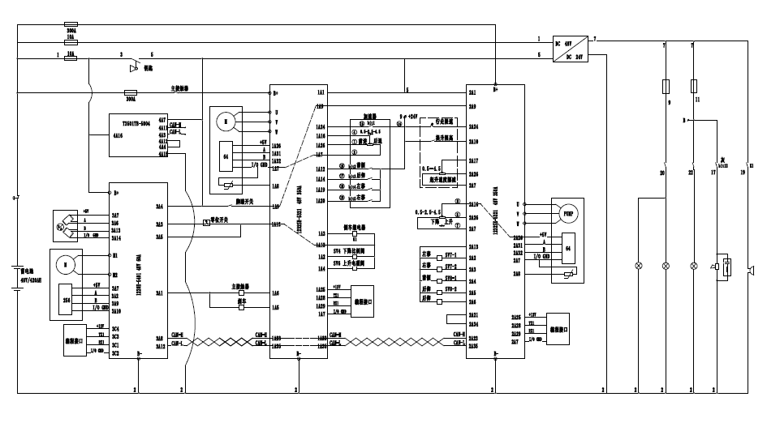

3.2[hydraulic](D:/360%E5%AE%89%E5%85%A8%E6%B5%8F%E8%A7%88%E5%99%A8%E4%B8%8B%E8%BD%BD/Youdao/Dict/8.9.6.0/resultui/html/index.html" \l "/javascript:;) [principle](D:/360%E5%AE%89%E5%85%A8%E6%B5%8F%E8%A7%88%E5%99%A8%E4%B8%8B%E8%BD%BD/Youdao/Dict/8.9.6.0/resultui/html/index.html#/javascript:;) [diagram](D:/360%E5%AE%89%E5%85%A8%E6%B5%8F%E8%A7%88%E5%99%A8%E4%B8%8B%E8%BD%BD/Youdao/Dict/8.9.6.0/resultui/html/index.html#/javascript:;)

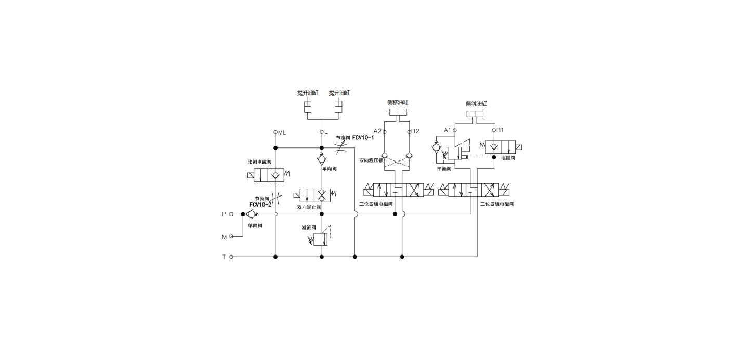

**Hydraulic oil inspection**

|  |  |  |  |
| --- | --- | --- | --- |
| **Appearance** | **odor** | **condition** | **results** |
| Clear not discoloration | good | good | can be used |
| color transparency | good | with other oil mix | check viscosity, if qualified can continue to use |
| Color changes like milk | well | mixed with air and water | to separate moisture or replace hydraulic fluid |
| The color becomes dark brown | not good | for oxidation | replacement of hydraulic oil |
| Clear color but small black spots | good | mix with other particles | can be used after filtering |

**4**Steering system

The steering system consists of rotating steering wheel, steering shaft, steering gear, electromagnetic braking, steering motor and reducer.

The drive unit is mounted on a rotary platform, and the steering function is realized by the steering motor reducer.

The steering motor with permanent magnet is controlled by the controller. On the one hand, the steering controller obtains the input signal from the steering wheel, on the other hand, it also obtains the signal of the actual Angle position of the wheel.

When turning, the speed of the forklift decreases automatically

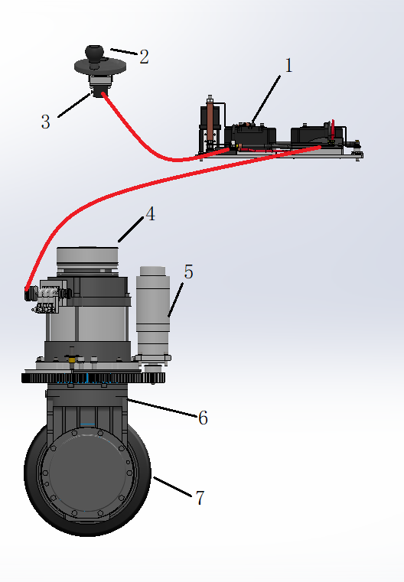

1. Controller 2. Rotating steering wheel 3. Electromagnetic braking 5. Steering motor 6. Reducer 7. Tires

When the vehicle is moving forward, rotate the steering wheel in the direction of S, then the vehicle rotation direction is S; If the steering wheel is rotated in the N direction, the whole vehicle rotates in the N direction.

When the vehicle is driving backwards, the steering wheel rotates to the DIRECTION of S, and the vehicle rotates to the direction of N; If the steering wheel is rotated in the N direction, the whole vehicle is rotated in the S direction.

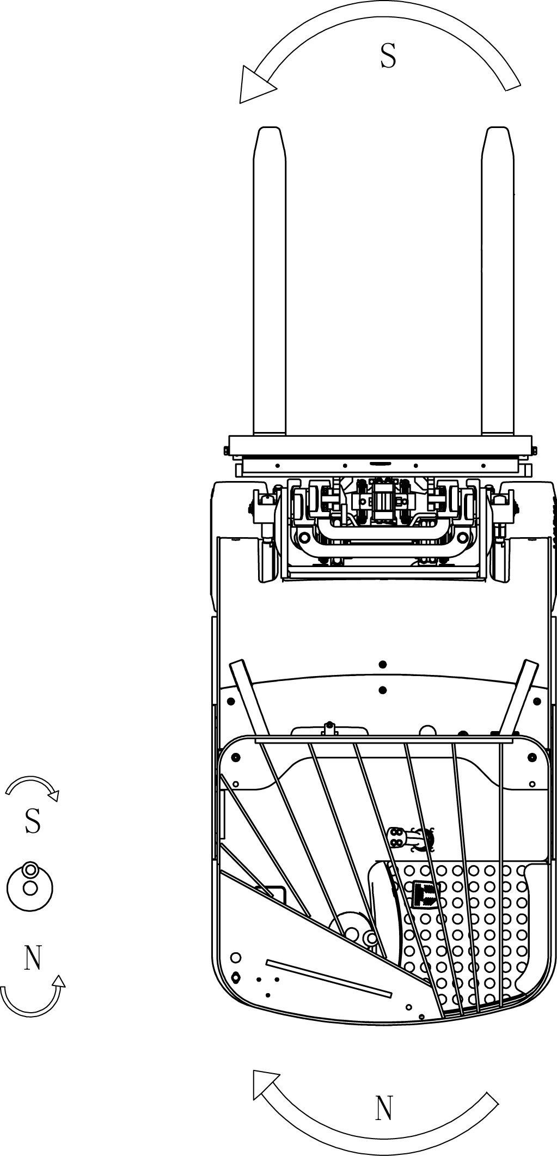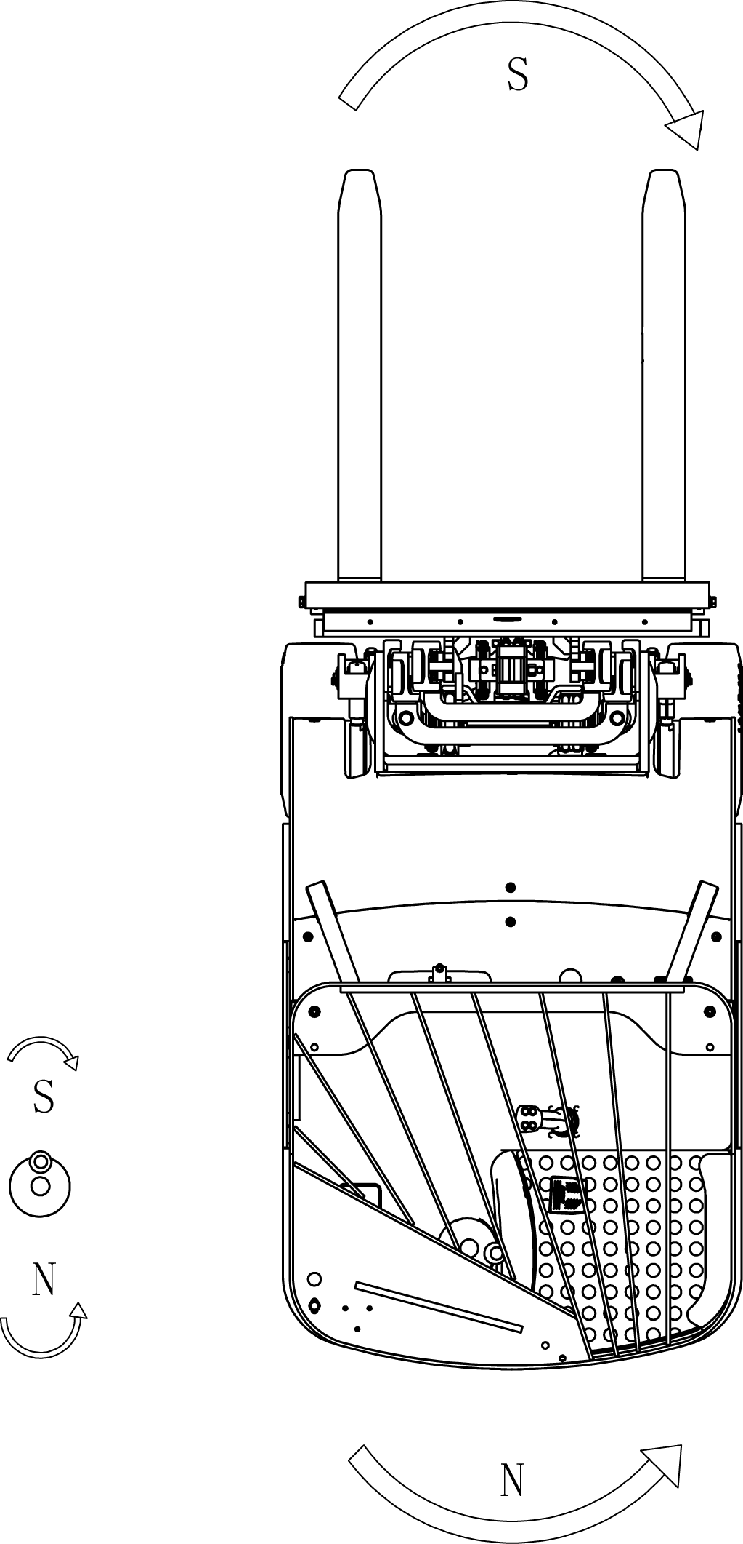

**6The braking system**

**Operating handle diagram**

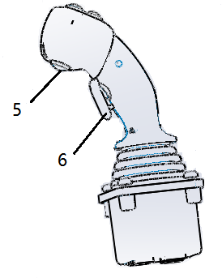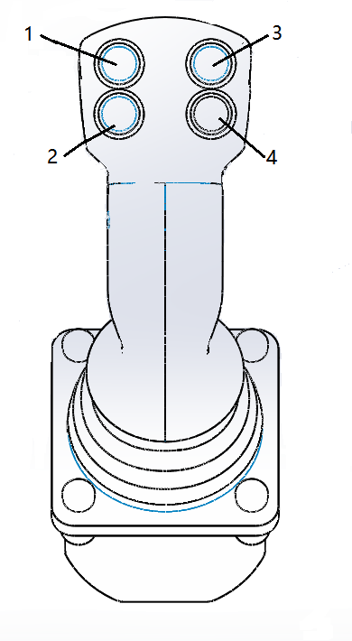

**1. Roll forward button 2. Roll back button 3. The left button**

**4. Right move button 5. Horn button 6. Safety switch button**

Insert the key into the key switch, turn to the right, turn the emergency stop switch in accordance with the direction indicated by the arrow above the button, and open the control circuit. Slowly push down the foot switch. Turn the steering wheel in the desired direction (forward or backward). Hold the handle lever (safety switch must be pressed) to B direction, forklift forward. Hold the handle lever (safety switch must be pressed) in the F direction, the forklift back. Observe the road condition and adjust the speed through the handle lever. When the forklift stops running, pull the handle lever slowly to the middle O position, and leave the pedal switch with the right foot to make the forklift stop completely. Place the fork in the lowest position and press the safety switch to remove the key.

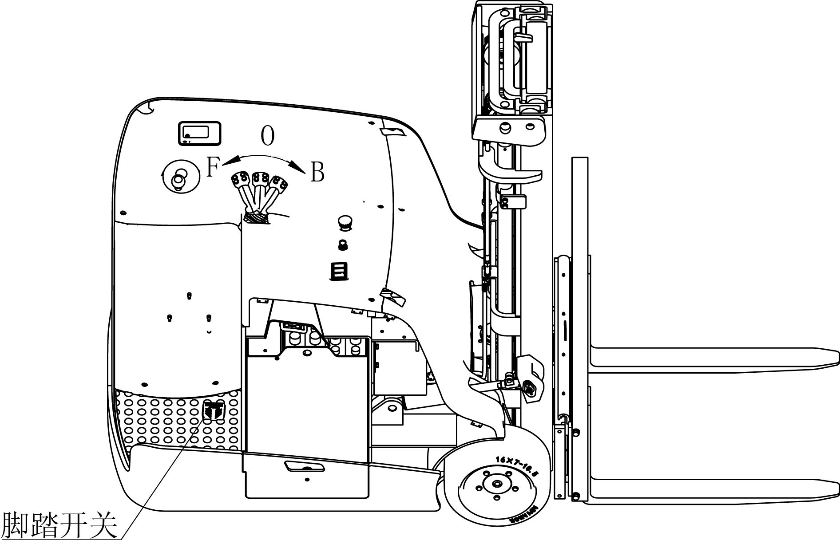

7. Hydraulic system

The hydraulic system consists of main oil pump, valve group, lifting cylinder, inclined cylinder and oil circuit.

The oil pump motor drives the gear pump to provide hydraulic power, the lifting cylinder is responsible for the lifting of the fork, the inclined cylinder completes the forward and backward tilt of the door frame, and the lateral cylinder completes the left and right-side movement of the tray frame. It has been debugged before leaving the factory. After leaving the factory, non-after-sales staff of our company or professional maintenance personnel are strictly prohibited to adjust themselves to avoid safety accidents.

7.1 Multiple valve sets

Multi-way valve consists of valve body, solenoid valve, relief valve and so on. The pressure of the main safety valve has been adjusted well before delivery, so users are not allowed to adjust it casually.

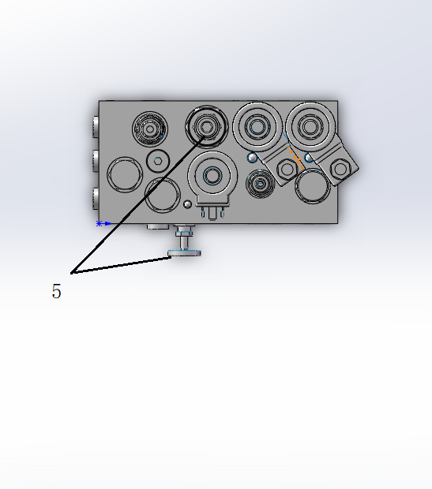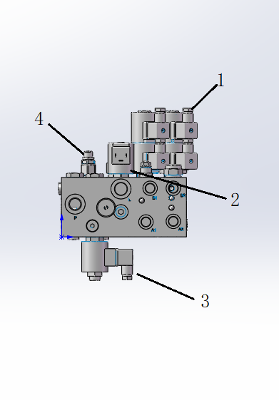

1, solenoid valve 2, proportional valve 3, check valve 4, countercurrent valve 5, throttle valve

7.2 Schematic drawing of lifting cylinder and tilting cylinder

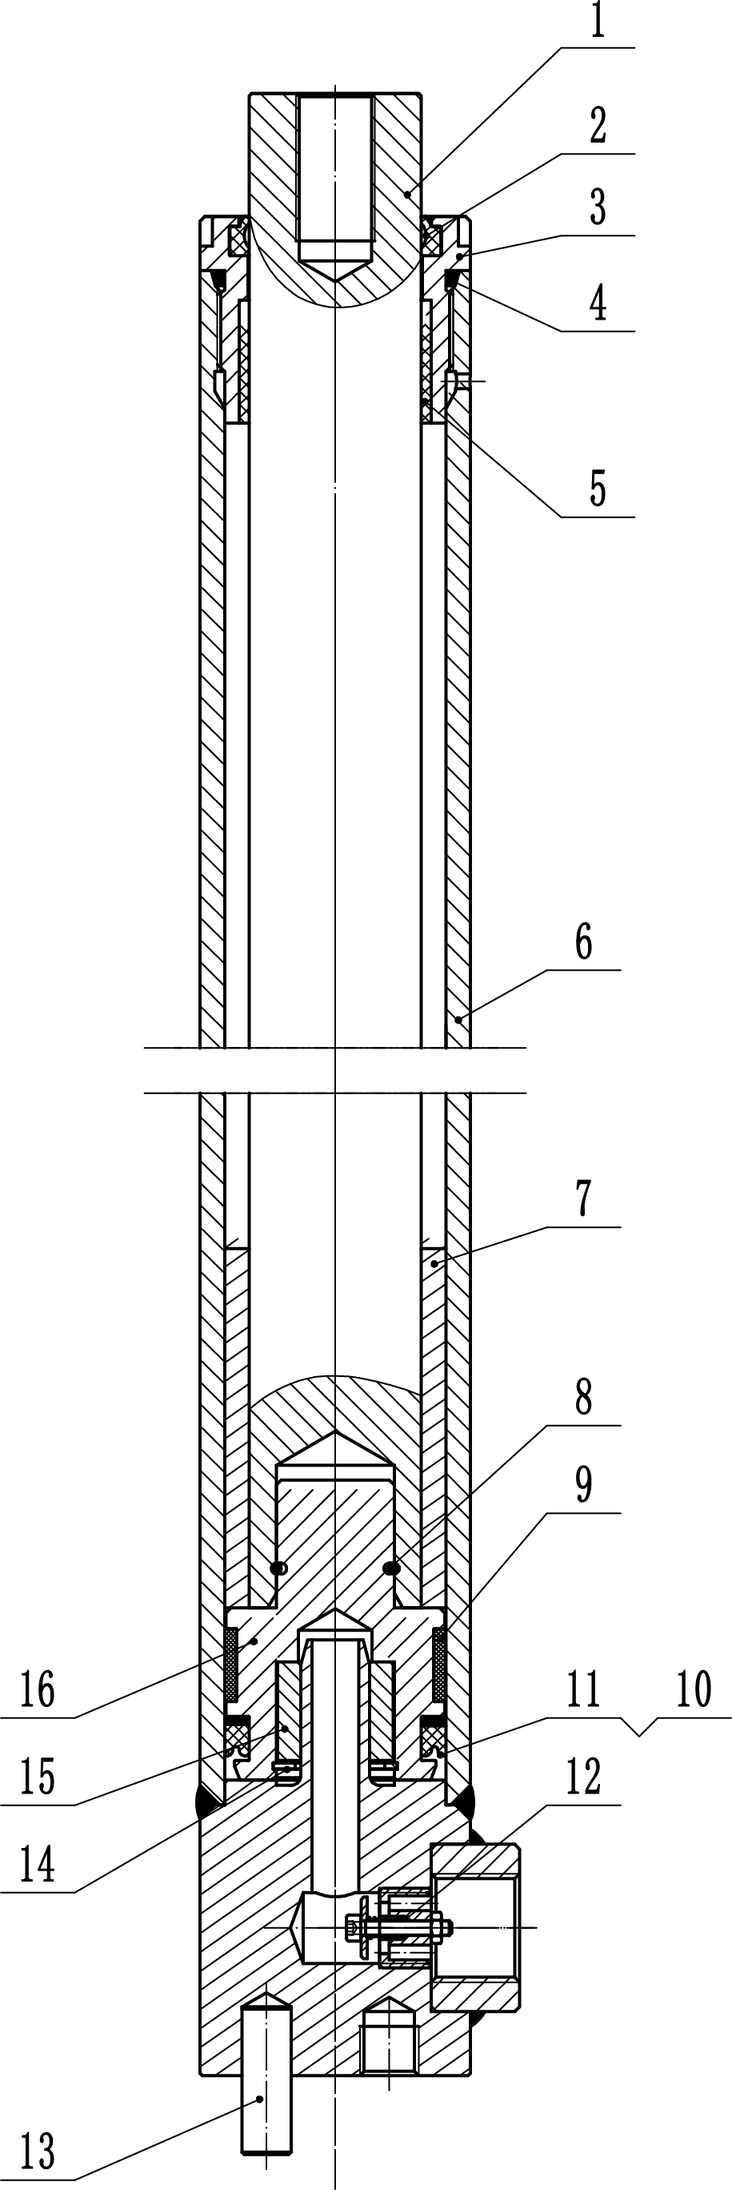

1. Piston rod 2. Dust ring 3. Cylinder head 4. Bearing 6. Cylinder block 7. Separator 8. Hole retaining ring 9. Supporting ring 10. Sealing ring 11. Retainer ring 12. Safety globe valve 13. Cylindrical pin 14. Buffer sleeve 16. Piston

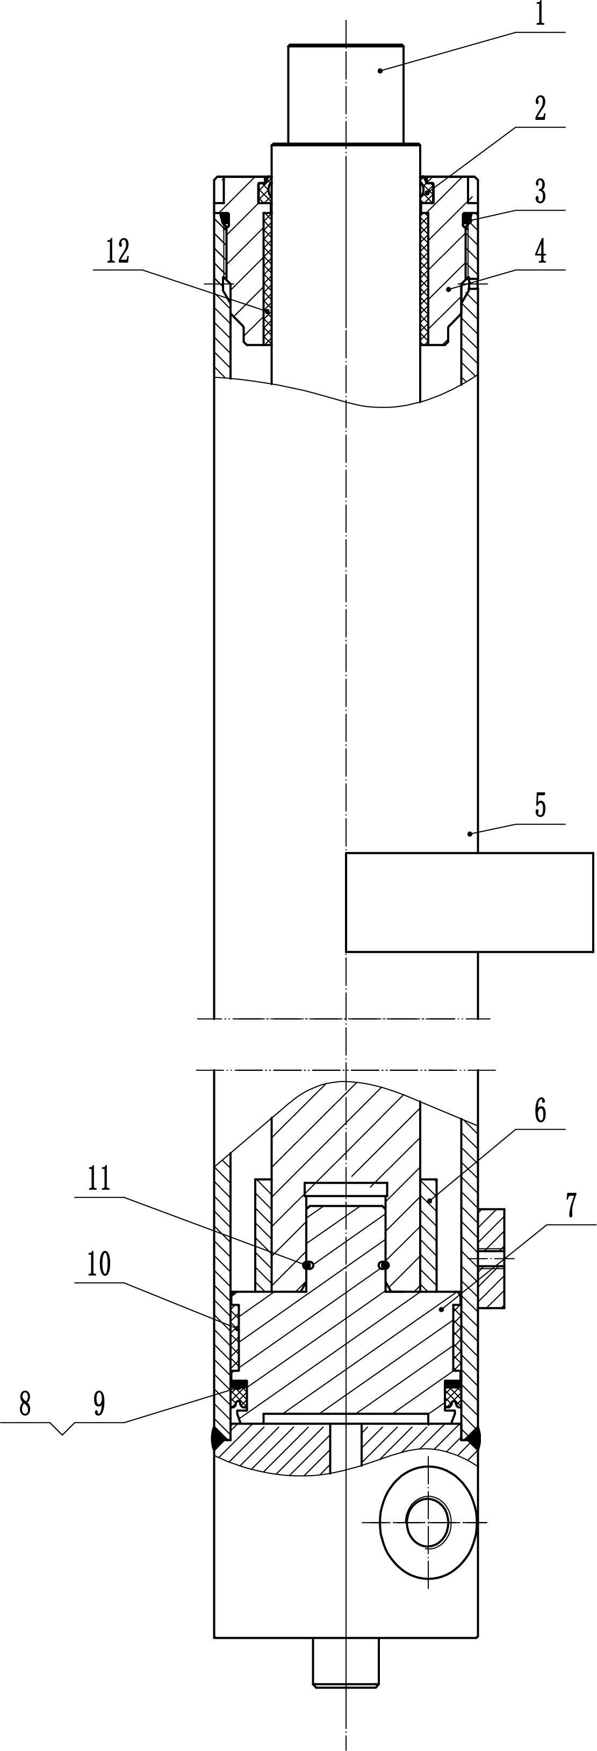

1. Piston rod 2. Dust ring 3. O-ring 4. Cylinder head 5. Cylinder block 6. Separator 7. Sealing ring 8. Retaining ring 9. Retaining ring 11. Hole with retaining ring 12. Compound sleeve

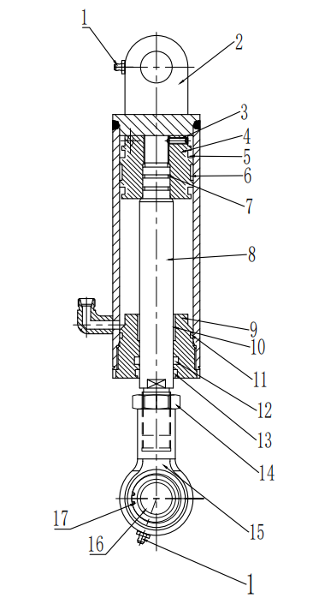

1. Oil cup 2. Cylinder block 3. Piston 5. Sealing ring for hole 6. Supporting ring for hole 7. Piston rod 9. Guide sleeve 10. Bearing 11. O-ring 12. Seal ring for shaft 13. Dust ring 14. Nut 15. Plain bearings 17. Elastic retainers for holes

8 Lifting system

The lifting system consists of internal and external door frame, cargo fork frame, retaining shelf, lifting cylinder, inclined cylinder, lifting chain and so on. It is the holding mechanism of forklift truck for loading and unloading operations. Forklifts are standard with a three-stage wide view frame.

8.1 Internal and external door frames

The three-level wide view frame is composed of an outer frame that cannot be lifted and lowered and two inner and middle frames that can be telescoped up and down. The lower part of the outer door frame relates to the drive axle, and the weight is mainly supported on the axle housing. The middle and outer inclined cylinder support of the outer door frame relates to the piston rod of the inclined cylinder, and the door frame can be tilted forward and backward by operating the multi-way valve. The inner and middle frame is a welded piece, which bears longitudinal and transverse loads through rollers and side rollers, and makes the frame move smoothly.

8.2 goods fork

Fork frame is equipped with rollers and adjustable gap side rollers, so that the fork frame along the inner edge of the channel steel smooth up and down movement, fork frame each side of the roller has three groups, fork mountain to the maximum height, above a pair of rollers will extend out of the inner door frame edge. Fork by hook hanging on the fork frame, and lock pin locked in the fork frame beam groove, fork spacing available manual adjustment, fork and fork frame using international standards (ISO) in order to universal and interchangeable.

8.3 Adjustment method of chain tightness

- Drive the forklift to a flat surface and lower the fork to the ground.

- Position with hinge bolts on one side of slide frame.

- After adjusting the length of chain section of hinge bolt on one side of lifting cylinder, tighten the nut on one side of lifting cylinder.

- At 1 meter above the ground, push the chain with your finger (about 5 kg force) so that the chain can move 20 mm.

9 Electrical System

The electrical system mainly includes battery, traction motor, pump motor, traction motor controller and pump motor controller, handle joystick, multi-way valve block controller, display instrument, combined control switch, instrument and lighting device, etc.

9.1 the display

The display has six built-in red liquid crystal displays, which provide the operator with some easy information about the operation of the vehicle's mechanism. Parameter adjustment key (left turn) 2. Speed mode switch key/Parameter Adjustment key (upturn) 3. Parameter adjustment key (right turn)

4. Parameter Adjustment button (Scroll down) 5. Parameter Adjustment button (Confirm) 6.7. Parking light

Fault indicator light 9. Lifting lock indicator light 10. Foot switch indicator light 11. Battery alarm lamp

9.2 the battery

First use an inner hexagonal wrench to unscrew the screw, take out the battery baffle, and then slowly pull out the battery from the side to replace, to ensure that the lifting equipment has enough load capacity. The lifting device must be pulled vertically to avoid damage to the battery case. The hook of the lifting device must be safe and reliable. The hook must not fall on a single cell in the battery pack.

- Press the emergency stop switch and power key switch to the OFF position so that it is in the cut OFF position.

- Remove the connector of the battery cable.

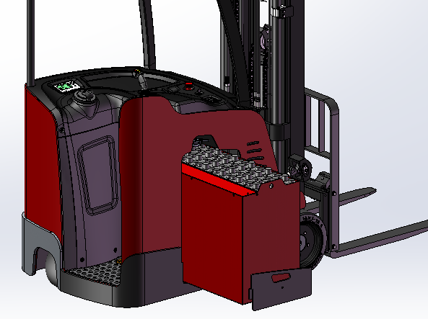

55、CURTIS Handheld unit

Precautions for operation:

The attention function of the hand-held unit is to facilitate vehicle inspection and maintenance. It is not allowed to adjust the controller parameters without the approval of the vehicle manufacturer, to avoid vehicle and personal safety accidents.

The hand-held unit will automatically save the modification parameters, just need to close the key switch, restart.

The CURTIS handheld unit can be connected in the event of a controller power or power failure

Vehicle fault reading process:

1. After connecting the handheld unit with the controller, open the key switch

2, From the menu list of CURTIS handheld units, find: Faults...

3. When the vehicle is running and the hand-held cursor flashes, there will be English fault content, which can be interpreted by referring to the fault code table

Vehicle signal detection:

1. After connecting the handheld unit with the controller, open the key switch

2, According to the menu list of CURTIS handheld unit, find: Monitor......

3. According to requirements, open the corresponding sub-item of the detection menu, run the vehicle, and observe the change of the hand-held value.

CURTIS Contents of handheld unit menu:

The Curtis 1313 handheld programmer is used to configure the Curtis electric control system. Through this programmer, you can adjust and save the set parameters, real-time monitoring of controller data and fault diagnosis

Warning: The control system can affect the vehicle's acceleration rate, deceleration rate, hydraulic system and braking.A dangerous situation can occur if the vehicle control system is not programmed correctly or exceeds safety.Only the vehicle manufacturer or an authorized service agent can program the control system

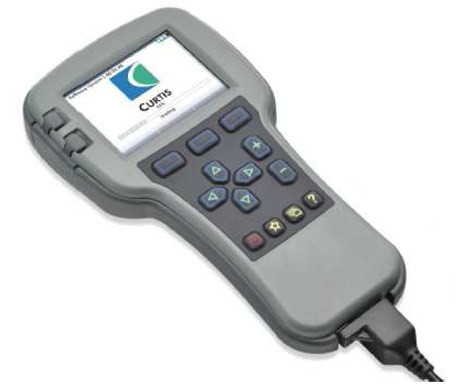

The programmer has two interfaces, one is used to communicate with the electric control, the other is used to communicate with the PC, the programmer has a battery box and a memory card slot

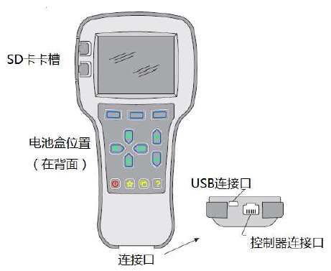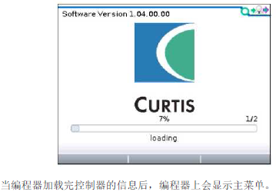

**The programmer is powered on**

The connection line of the handheld programmer can be connected to the controller by inserting the programming port of the controller. After connecting the controller, the handheld programmer will be powered on automatically and the control information will be displayed on the programmer.

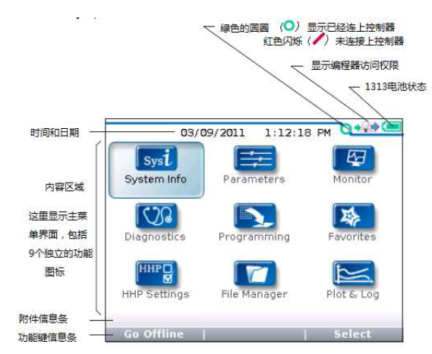

The function keys

Since the function of the three keys is determined by the specified content, the three keys are blank.At any given time, the function of the button is displayed on the LCD screen above.

Direction arrow key

The displayed information can be selected up, down, or left by four directional buttons.

+ / - buttons

You can add and subtract parameters by using these two keys.In addition, "+" can mean "Yes" and "-" can mean "No".In some cases, it can also be used as a scrolling option.

Power key

When the programmer inserts a controller that has been powered on, the programmer does not have to press the power button to use it. The programmer wil

Collect keys

There are two ways to enter the Favorites menu. You can enter Favorites from the main menu or press this key

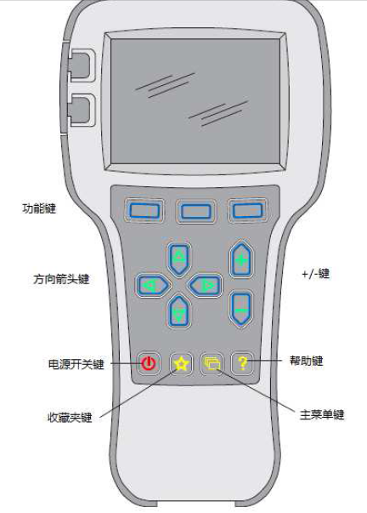

The menu structure

The main menu consists of nine sub-menus, and each sub-menu is displayed with a specific icon. Each item in the sub-menu is arranged by hierarchy.

Some menus contain only one item of information, but most menus contain more than one item of information and open each item folder to access the next level of sub menus. Expand the table through the grid option, enter a group of execution commands through the dialog box option, and return to the upper menu regardless of the interface by pressing the left direction button.

The names of all nine sub menus are shown in bold on the main menu and below the icon. When entering the stepped menu, the name of the sub menu or the path you are in is displayed at the top of the screen.

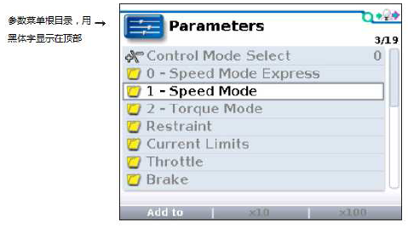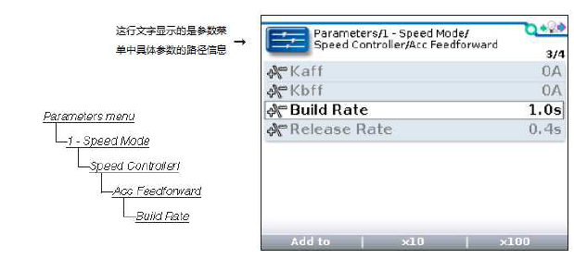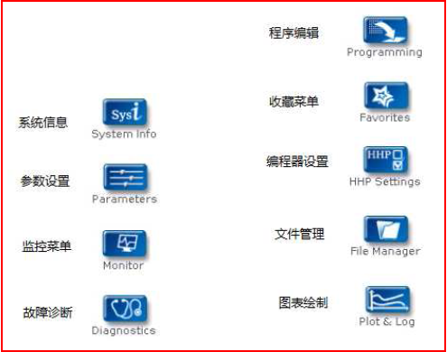

Fault Diagnosis menu

On the main menu, Select Diagnostics and press Select to access the Fault diagnosis menu. The Fault diagnosis menu contains Present Errors current faults and Fault History historical faults

Note: Sometimes a fault caused by a temporary event captured in the circuit is not a system fault. You can determine whether the fault exists by restarting the system and observing whether the fault disappears automatically.

The historical faults folder lists all faults encountered after the last historical fault is cleared. By clearing the fault content in the entire folder, you can record the historical faults again.

。

“Clear All is used to Clear historical fault folders. A function key is highlighted only when there are historical failures in the historical failures folder and grayed out when there are no historical failures.

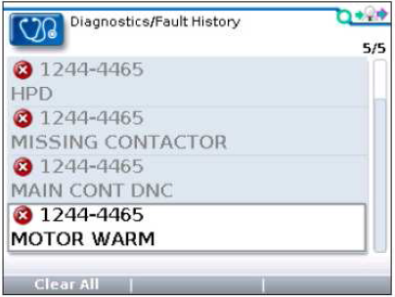

Programming menu

On the main menu, Select the Programming icon and press Select to access the menu. Save and restore parameter Settings files (.cpf files) through programming menus

Save.cpf File (Save.cpf File)

Use the save. CPF file function in the programming menu to back up the currently set parameters. You can save as many.cpf files as you want, and you need to name each.cpf file differently

Restore. CPF File (Restore.cpf File)

Restore. CPF File The. CPF File saved earlier can be used to replace the. CPF File of the current controller.When the data recovery is complete, a dialog box is displayed asking you to restart the system.

